General Google Docs Tips and Tricks

Creating Docs:
Uploading, Converting & Downloading Docs:
Formatting Google Docs:
Document Sharing in Google Docs:
Sharing a Doc:
Share –– See Who Has Access
Share –– Get the Link to Share
Share –– Email as Attachment
Share –– Set Notification Rules
Using Shared Folders:
Editing a Shared Doc:
Chatting While Editing:
Removing Editors and Viewers From a Shared Doc:
Revert to Previous Version
Searching for Docs:
Organizing Docs:
To move an item into a Collection:
Remove docs from Collections:
Renaming & Editing Collections:

Creating Docs:
You can Create New documents (similar to Word), spreadsheets (similar to Excel), presentations (similar to PowerPoint) or forms. You can also create Collections (formerly called Folders) to organize items.

Uploading, Converting & Downloading Docs:
You can Upload existing documents right into Google Docs as long as they are smaller than 25MB. Google Docs accepts many format types such as Word, Works, Excel, Powerpoint, Open Office, Apple pages, txt, rtf, html, pdf, wmv and many more.

If you upload a 2010 Power Point presentation, convert it to a Google presentation so that you can edit and share, but then you can only view it - try converting the Power Point presentation to the 97-2003 format first and then try upload & convert again. There seems to be a bug with the 2010 version.

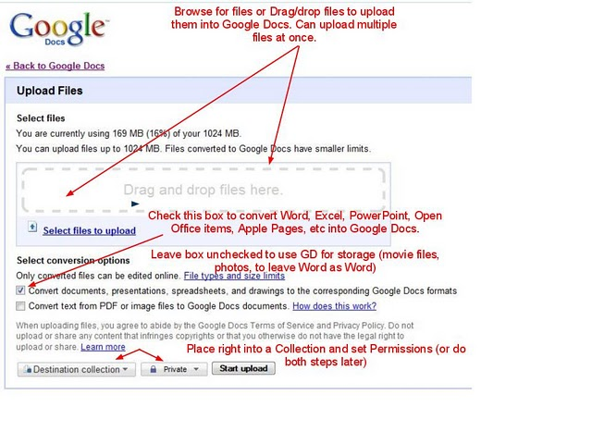

You can download Google Docs back into Word, Excel, Powerpoint and other formats. This can be done to save a backup copy to your own computer . To download a document, click its name to open the doc and then select File – Download as

Formatting Google Docs:
The formatting capability of Google Docs is not as good as Microsoft Word but improves constantly. If absolute proper formatting is an issue, such as a formal research paper, you can create and edit using Google Docs and then download the final product back into Word for final formatting and printing.

Click View to turn on/off
- comments
- ruler
- spell check
- equation toolbar
Click Insert to add
- images (upload from computer, insert by URL, find in Google Image search, include from Picasa
Web Album)
- equations
- drawings
- comments
- footnotes
- special characters
- lines
- page breaks
- header/footer
- bookmarks
- table of contents
Click Format or buttons at top to change
- bold, italics, underline font
- font type, size, color
- text background (highlighting) color
- numbered or bulleted list
- indentation
- paragraph style
- text alignment
- line spacing
  - Click Format to change strikethrough, superscript, subscript
Click Tools to
- translate the document
- define a word
- perform a word count
Click Table to insert or update a tab

Document Sharing in Google Docs:
Only 200 people may be invited as viewers, collaborators, or combination of the two for each document

Only 10 people can look at or edit a document or presentation at the same time. However, 50 people can look at or edit a spreadsheet at the same time. You can also publish a document so an indefinite number of people may view it.

There are many levels to sharing a document. You can invite people just to read (view) or to collaborate (edit) on a document with you. You can give them the ability to share with even more people or you can maintain control of who has access. And you can determine if the invited user needs to sign in to Google Apps to view or edit, or if they can see the document immediately from their email.

Sharing a Doc:
Click the box next to the item or multiple items you want to share within the Docs list (if you don’t see the document you want, select All Items or another category on the left), and then the Share button in the toolbar. You can also open the document by clicking on it and then selecting the Share button at top right (which offers more sharing options). PDFs can only be shared from the Docs list.

Share –– See Who Has Access
  - You can see who already has access and whether they are editors or only viewers
  - You can decide if sign-in to Google Apps is required to view this item under the People with Access tab
  - You can invite more people to edit or view
  - You can also “lock up” a document so that it cannot be shared with people you did not invite.
- Click Advanced Permissions
- Check or uncheck the box in front of Allow editors to invite others to edit or view
- Check or uncheck the box in front of Allow invitations to be forwarded

Share –– Get the Link to Share
  - If you click on the box Allow anyone with the link to view, then a link is created so that you can email or IM a document out.
  - You can also click a box allowing the recipient to edit the document. This feature only works within a domain (either lunenburgonline.com for admin/faculty or lunenburgschools.net for faculty/students).

Share –– Email as Attachment
  - You can email the document as an attachment

Share –– Set Notification Rules
  - Set if and how you will be notified if changes are made to a shared document

Using Shared Folders:
An entire folder can be shared across accounts. This means that anyone with access to the
Shared Folder can add documents and these will be shared with everyone who has permission to edit or view the folder. This could serve as a drop-box for teachers.
- Create a new folder. When it appears on the left side of the screen, right click it and select Share. Share the folder just as you would a doc.
- To add docs, either drag them over to the folder or click the box in front of them in the Docs list and select that folder from the dropdown list.
- Any subfolders and docs within that shared folder have the same sharing permission level. If the entire folder is shared with someone, than anything in that folder is shared with that person. Any docs added to the folder also share the same permission. However, If someone creates a doc within the shared folder, then he or she can specifically limit who sees or who can edit/view that doc. To change the permission on a particular doc, open that doc and click Share – Invite people – View who has access. Here you can see who has access and the type of access. You can change access to Can Edit, Can View or None to remove access altogether from the doc.
- Shared folders appear under Folders Shared With Me on the left and also look different (with a little person icon) in the Docs list.

Editing a Shared Doc:
- Changes are made in real time
- If someone else is editing a document at the same time as you, a box with their name appears at the top of the screen and notification of edits or saves appear as well
- To check to see what someone has changed in a shared document, click File – See Revision History.
- You can click the boxes in front of two revisions and select Compare Checked. Any changes made will appear in a different color.
- To select on older version as the “correct” version, click the revision number. When the doc opens, check that it has the correct information and click the Revert to the one button. You can always go back and click another revision version later. You can also click the Newer and Older buttons to walk step by step through each revision.
- Editors can leave a comment on the document by clicking Insert - Comment. Clicking on the comment box allows an editor to delete the comment, insert the comment right into the text, or change the color of the comment box.

Chatting While Editing:
When you see an editor’s name appear in the upper right side of the screen, click the name and a chat window will appear

Removing Editors and Viewers From a Shared Doc:
- To remove all editors or viewers from a document, click Share – See Who Has Access - People With Access – remove all (located at bottom of screen)
- To remove an individual editor or viewer, find their name in the People With Access list and change status to None. Be sure to click Save & Close. Next time the other user opens Google Docs, the doc will no longer be listed in their account.

Revert to Previous Version
- Open the Doc
- Click File - See Revision History
- A Revision History pane opens on right with a few major changes
- To see EVERY change, click the Show more detailed revisions button at bottom of the Revision History pane

To see how different revisions changed the Doc, click them on right and you'll see the changes that were made. Changes made by different users will be shown in different colors.

To restore a previous version, click the blue Restore this revision link inside the correct revision in the pane.

Searching for Docs:
Search for docs using the search box at top of screen.

Organizing Docs:
You can organize your Docs from the Google Docs List. To access the Docs List from within a Doc, click the multicolored Google docs logo at the top left of the screen.
- Use stars to mark important docs. To see only starred docs, select Starred from menu on left
- Hide docs you don’t want to trash, but don’t want cluttering up your docs list (click document box, click More Actions button – Hide)
- Move docs into folders or subfolders (as of Jan 2011 Folders are now called Collections)
- Click Create New button and then Collection. Name collection and click Save.

To move an item into a Collection:
  - either click the Actions link on the same row as the item and select Organize
  - or click the white space next to the name of an item and click Organize from the pane on the right
  - when Collections list appears, click box in front of correct Collection, and Apply changes
- You can put docs in more than one Collection. Simply check the boxes in front of the correct ones.

Remove docs from Collections:
- Click the Actions link on the same row as the item and select Organize
- Uncheck box in front of Collection and click Apply changes. The doc will be removed from the Collection.

Renaming & Editing Collections:
- Right click a Collection name from the list on the left to rename or change its color.

